Guest Speaker

Dr. Jenny Heathcote FRCPC, MD
Enjoy ...wonderful views of the racetrack
Fabulous buffet
Be in the Winner’s Circle!
SILENT AUCTION
50/50 DRAW

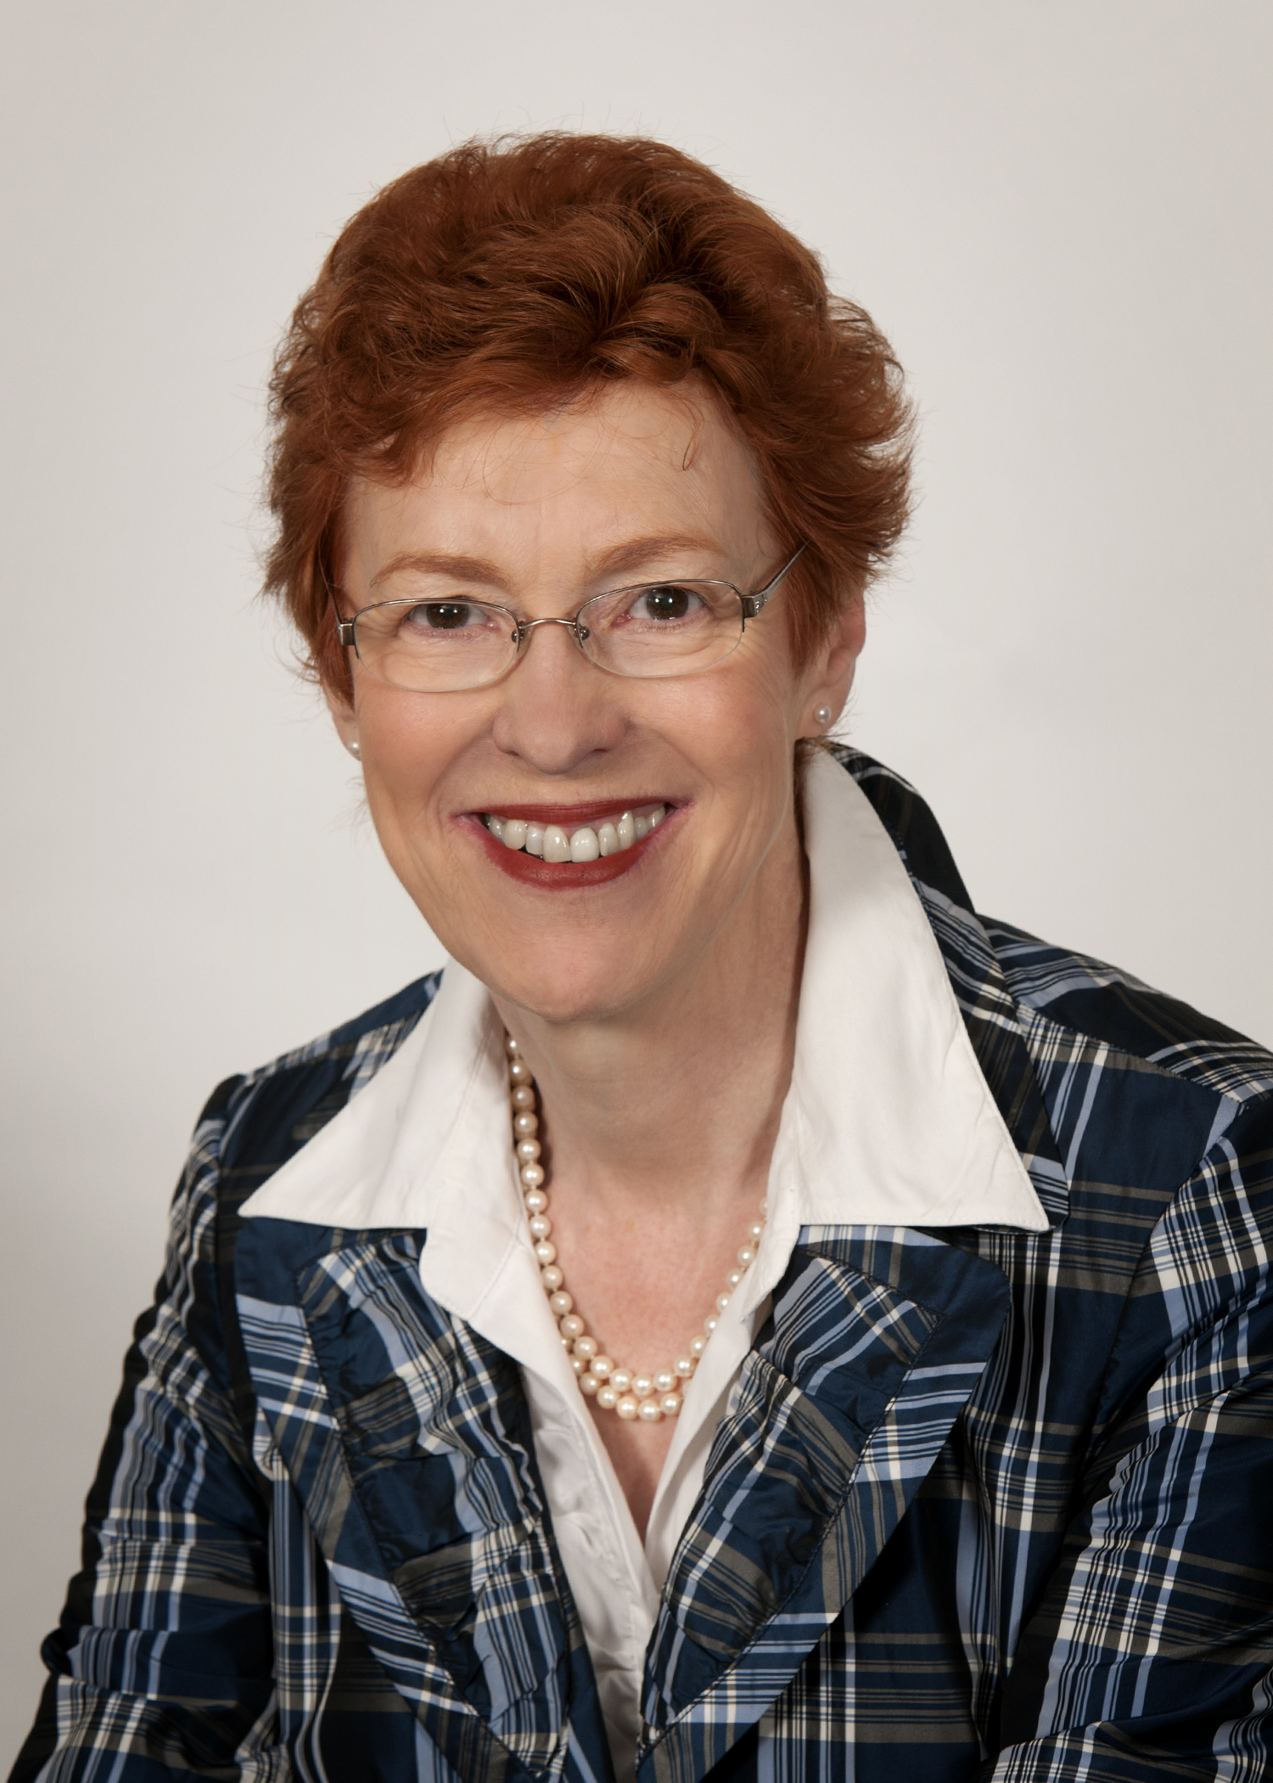
Join us for an exciting afternoon of trackside racing & dining at Woodbine!
7th Annual ‘Day at the Races’ Fundraiser
Sunday, June 10th, 2012
12.15 pm Welcome
12.30 pm Buffet
1.00 pm Post Time

Adults : $90.00, Children 5 to 12 yrs - $25.00 (at cost) Children under 5 yrs – free

To reserve tickets please use the form provided & to donate an item for the silent auction contact the Society.
A tax receipt will be issued for the allowable portion of an adult ticket, children 5-12 years are at cost only price

~~~~~~~~~~~~~~~~~~~~~~~~~~~~~~~~~~~~~~~~~~~~~~~~~~~~~~~~~~~~~~~~~~~~~~~
For your records Ticket deadline – MAY 31, 2012
Contact information
Toll Free: 1.866.441.3643
Email: fundraising@pbc-society.ca

Adults: $90.00 No of tickets _____ _x $90.00 = $ _________
Children 5 -12 years No of tickets______ x $25.00 = $ _________
TOTAL $ _________
Children under 5 years _______ Free
Payment method: ____ Cheque ____ Visa ____ MC

Thank you for your support

Detach & mail the section below to the Canadian PBC Society
-------------------------------------------------------------------------------------------------------------------------------------------------------.

Mail to: Canadian PBC Society
4936 Yonge Street, Suite 221. Toronto. ON. M2N 6S3

Adults: $90.00 No of tickets _____ x $90.00 = $ _________
Children 5 -12 years No of tickets______ x $25.00 = $ _________
TOTAL $ _________
Children under 5 years _______ Free

Payment method: ____ Cheque enclosed ____ Visa ____ MC
Card # ____________________________ Expiry Date ___ / ____
Signature __________________________________
Name [Print] ________________________________ Phone ______________________________
Address _____________________________________________________________________
Email _____________________________

